Using Models to Understand Cellular Respiration

A scientific model is a simplified representation of reality that highlights some key features of a process like cellular respiration. A good scientific model helps us to understand the process it represents.

1. What key features of cellular respiration do you think should be included in a scientific model of this process?

These chemical equations are a model that provides an overview of cellular respiration. The curved arrows represent coupled chemical reactions; the top reaction provides the energy needed for the bottom reaction. | 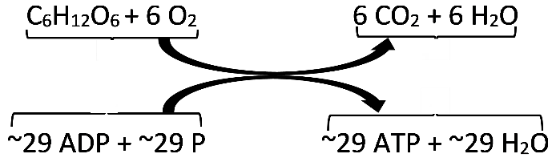

2a. Describe in words what these chemical equations tell us about cellular respiration.

2b. Add a reverse arrow to show the hydrolysis of ATP.

2c. How is the hydrolysis of ATP useful for a cell?

2d. Why do cells need to carry out cellular respiration?

3. This table lists the input molecules for cellular respiration. For each input molecule, explain how our cells get this molecule or how this molecule is made inside each cell.

Input Molecule | How our Cells Get this Molecule or  How this Molecule is Made Inside Each Cell
Glucose
Oxygen
ADP + P

The figure below presents another model of cellular respiration. It shows the three main stages of cellular respiration, which are glycolysis, the Krebs cycle, and the electron transport chain + ATP synthase. Most of the ATP is made inside an organelle, called a mitochondrion.

4a. Circle the input for cellular respiration that is shown in this figure.  4b. What output from cellular respiration is shown in this figure?  4c. Which inputs and outputs of cellular respiration are missing from this figure? (Hint: Check the chemical equations on page 1.) | 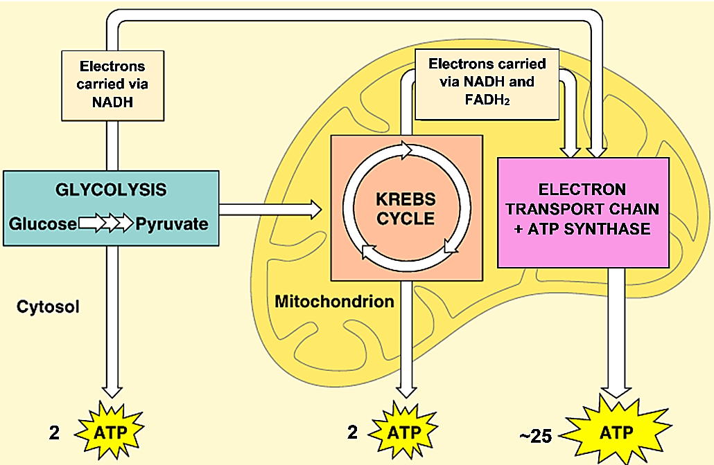

Missing inputs: | Missing outputs:

5a. Underline ATP synthase in the figure.

5b. What type of molecule do you think ATP synthase is? What do you think it does?

6. Describe each of the three main stages of cellular respiration by choosing the best matches. (Give one match per blank, and use one of the matches more than once.)

Glycolysis ___ ___
Krebs cycle ___
Electron transport chain + ATP synthase ___ ___

a. Makes most of the ATP produced by cellular respiration
b. Occurs in mitochondria (plural of mitochondrion)
c. Occurs inside cells, but not in mitochondria
d. Uses glucose as an input

7. Explain why mitochondria are often called the powerhouse of the cell.

8a. Different types of models have different advantages for understanding cellular respiration. Complete the table below to describe the advantages of each type of model.

What are the advantages of this model for understanding cellular respiration?
The chemical equations on page 1
The figure on page 2

8b. What are some features of cellular respiration that are shown in both of these models?

9. Use what you have learned to construct another model of cellular respiration in this drawing of a cell with a mitochondrion. (In an actual cell there are many mitochondria.)
- Write the three main stages of cellular respiration in the appropriate blanks.
- Label each arrow with an appropriate input or output. (For simplicity, this diagram omits NADH and FADH₂, which are discussed on the next page.)
- Additional information you will need:
  - The Krebs cycle produces CO₂.
  - The electron transport chain needs O₂ as an input and produces H₂O.

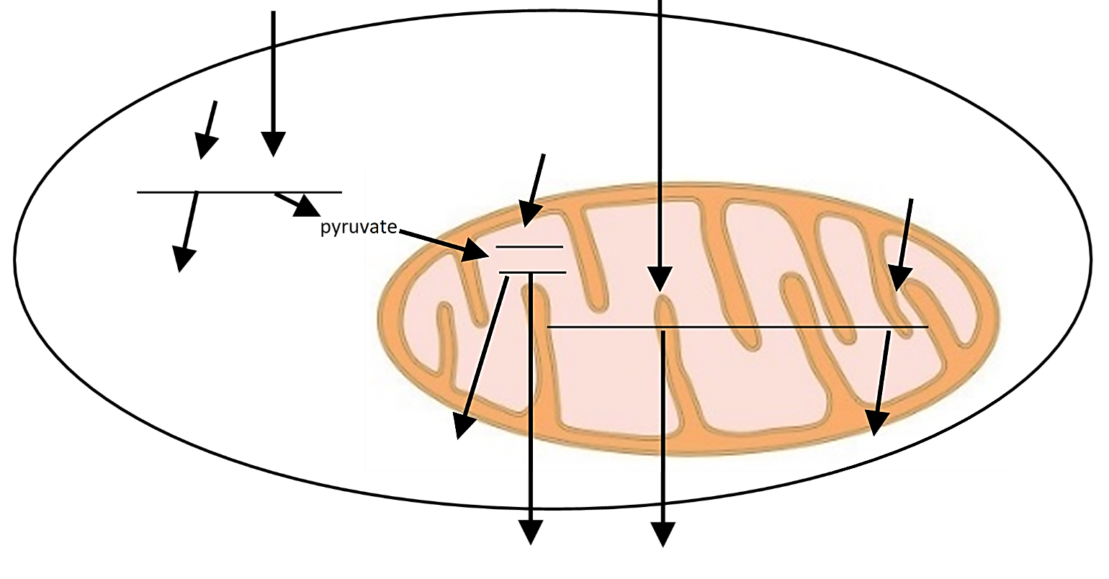
Understanding the Structure and Function of Mitochondria

In biology, structure is related to function. One prominent feature of the structure of a mitochondrion is an inner membrane with many folds. The main function of mitochondria is the production of ATP. These observations suggest the hypothesis that the extensive, folded inner membrane contributes to the production of ATP. We will investigate this hypothesis. | Cross-Section of a Mitochondrion (actual length ~1 µm)  The intermembrane space is the space between membranes.

10. The figure below shows a magnified view of a very small part of the cross-section of the mitochondrion in the figure above. Draw a rectangle in the figure above to show a possible location of the magnified view in the figure below. (Hint: Check the labels on the left in the figure below.)

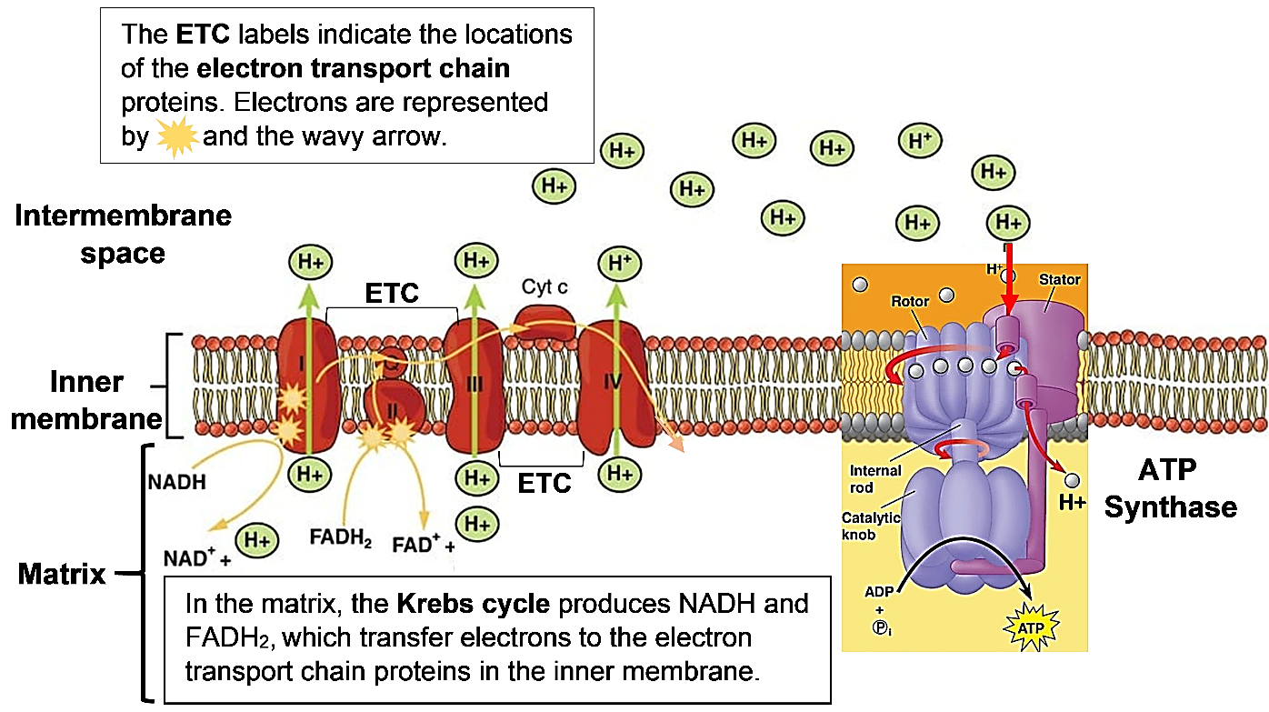

11. The sentences below explain how the electron transport chain (ETC) works with ATP synthase to make ATP. For each lettered sentence, write the letter of the sentence in the relevant part of the above figure.

- When activated by NADH and FADH₂, the electron transport chain proteins pump H⁺ from the matrix to the intermembrane space.
- As a result, the concentration of H⁺ is higher in the intermembrane space and lower in the matrix.
- Because of this difference in H⁺ concentration, H⁺ tends to diffuse across the inner membrane from the intermembrane space to the matrix.
- The only place that H⁺ can diffuse across the inner membrane is through the channels in the ATP synthase molecules.
- The movement of H⁺ through ATP synthase provides the energy to make ATP. This is similar to how the flow of water through a turbine provides the energy to generate electricity.

Drawing A shows a magnified cross-section through a real mitochondrion. Drawing B shows a magnified cross-section through a hypothetical mitochondrion with an inner membrane that does not have any folds.  12a. Which mitochondrion would be expected to produce more ATP?  - mitochondrion A  - mitochondrion B  12b. Explain your reasoning. | 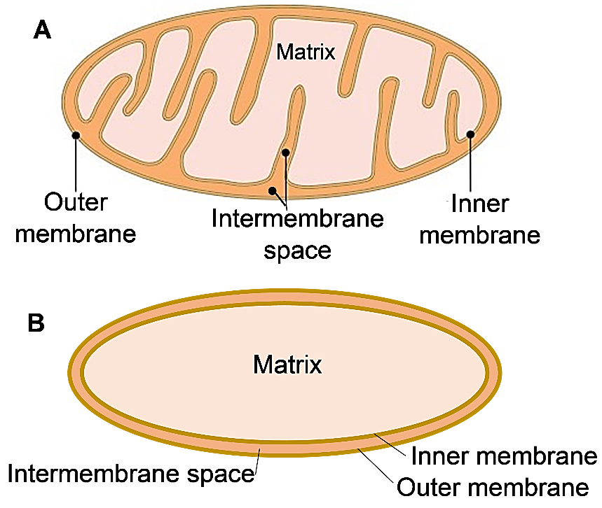

13a. Imagine a mitochondrion that has no inner membrane, so there is no intermembrane space. The electron transport chain proteins and ATP synthase are in the matrix. Could this ATP synthase make ATP? yes ___ no ___

13b. Explain why or why not.

14. In biology, structure is related to function. How does the extensive folded inner membrane of mitochondria illustrate the relationship between structure and function? (Hint: Use your answers to questions 12 and 13 as the basis for your answer to this question.)

By Dr. Ingrid Waldron, Dept Biology, Univ Pennsylvania, © 2023. This Student Handout (and a simpler version) and Teacher Notes (with background information and instructional suggestions) are available at https://serendipstudio.org/exchange/bioactivities/modelCR. This activity is intended to follow "How do organisms use energy?" (https://serendipstudio.org/exchange/bioactivities/energy).

